Lumberton FFA
Member Handbook

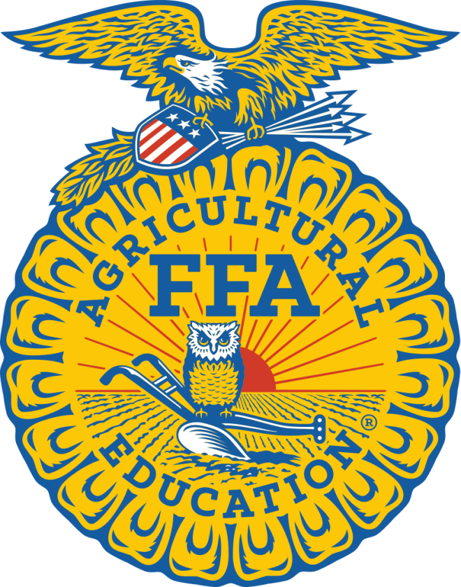

2021-2022

Lumberton FFA: Cultivating Leadership
Table of Contents

Welcome……………………………………………………………..3
Communications…………………………………………………….4
Award Opportunities…………………………………………..........5-6
Leadership Development Events…………………………………..7
Career Development Events ………………………………………8
FFA Creed and Motto……………………………………………….9
FFA Fundraising Activities…………………………………………10
FFA Member Participation…………………………………………11
FFA Dues/Jr. FFA…………………………………………………..12
FFA and Agriscience Department Code of Conduct…………...13
Supervised Agriculture Experience Program……………………14
Livestock Showing Requirements………………………………...15-17
Livestock Show Supply Source List………………………………18
Forms………………………………………………………………...19-22

Dear Friends,

Welcome to the 2021-2022 school year of Lumberton FFA. It is great to see all of the new and returning FFA faces. Your officer team is planning a fun filled year, so I hope you are all as excited as we are. We hope that everyone will attend the many activities and meetings available. The FFA is a great way to make new friends and establish friendships with not only students of your own school, but schools all across the state. Friendships you make this year can last a life time. With everyone’s support our chapter will achieve greatness. Here’s to an exciting year.

Sincerely,

The Lumberton FFA Officers

President Jackson Akers
Vice President Riley Duplechain
2nd Vice President Holli Walls
Secretary Emily Smith
Treasurer Skylar Lerette
Reporter Emmi Peavy
Sentinel Hayleigh Kruttlin
Student Advisor Delta Shoemaker

Advisor Reid Tipton artipton@lumbertonisd.org Ext: 1506

Advisor Kyle Rich ktrich@lumbertonisd.org
Ext: 7899

Advisor Kaycee Hays kkhays@lumbertonisd.org
Ext: 1504
.
Advisor Sami Anderson slanderson@lumbertonisd.org
Ext: 7899

LISD High School 409-923-7890

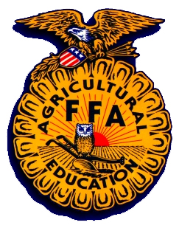

Communications


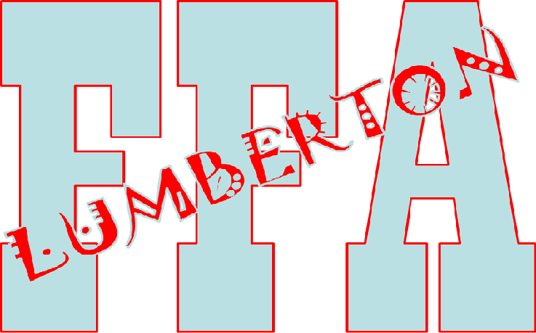


FFA Text Message System

To receive FFA Announcements on your cell phone through Remind 101. To join send a text to: 81010 with the message: @27kc4g2. This will enroll you in the Lumberton FFA Remind 101 System.
FFA Website

Visit the Lumberton FFA Website located at:
www.lumbertonffa.ffanow.org
The FFA website includes a calendar of events, information about the organization, pictures and more!
FFA Social Media

The Lumberton FFA has a group site on Facebook, and we’re on Instagram @lumbertonFFA or like us on Facebook at The Lumberton FFA. These sites are updated regularly with events and pictures.
Proficiency Award Areas

The following awards can be given to students who excel in any of the following areas and who complete a record book and application:

Agricultural Communications
Agricultural Education
Agricultural Mechanics Design and Fabrication
Agricultural Mechanics Energy Systems
Agricultural Mechanics Repair and Maintenance
Agricultural Processing
Agricultural Sales
Agricultural Services
Agriscience Research
Beef Production
Dairy Production
Diversified Agricultural Production
Diversified Crop Production
Diversified Horticulture
Diversified Livestock Production
Emerging Agricultural Technology
Environmental Science and Natural Resources
Equine Science
Fiber and/or Oil Crop Production
Food Science and Technology
Forage Production
Forest Management and Products
Fruit Production
Goat Production
Grain Production
Home and/or Community Development
Landscape Management
Nursery Operations
Outdoor Recreation
Poultry Production
Sheep Production
Small Animal Production and Care
Specialty Animal Production
Specialty Crop Production
Swine Production
Turf Grass Management
Vegetable Production
Veterinary Science
Wildlife Production and Management

FFA Degrees and Awards

Students who participate in FFA events and activities can be eligible for degrees and awards on the chapter, area, state, and national levels. Members interested in attaining these awards must complete required record books and applications, and other guidelines set by the National FFA. These guidelines can be found in the FFA Manual.

FFA Degrees

Greenhand Degree
Chapter Farmer Degree
Lone Star Degree
American Degree

Star Awards

Outstanding members at each degree level are selected for the Star Awards on all FFA levels.

STAR GREENHAND
STAR CHAPTER FARMER
STAR LONE STAR
DeKalb Award

Scholarship Opportunities

$1,000 - $20,000
San Antonio Livestock Show Program
Houston Livestock Show Program
National FFA Foundation
Texas FFA Scholarships
Ford Motor Company
Leadership Development Events

Students will receive meal money for district, area and state contests. Students will not receive any meal money for Invitational Contests. All contest teams are subject to change based on student interest and participation.

Chapter Conducting - Teams conduct a mock chapter meeting to demonstrate knowledge of basic parliamentary law and the use of correct parliamentary procedures. At the conclusion of the meeting, team members are asked questions regarding parliamentary law.

Prepared Public Speaking - Speaking Development Events are designed to develop the ability of all FFA members to express themselves on a given subject. Students are encouraged to develop their communication skills and learn to formulate their remarks for presentation in a variety of situations.

FFA Quiz - An exam testing team members’ understanding of the FFA, agricultural education, current agricultural events and parliamentary procedure is given.

Creed Speaking - A member presents the FFA Creed from memory and answers questions about its meaning and purpose. This event is just one way to boost self-confidence, earn recognition, and develop powerful, organized and professional communication skills.

FFA Skills - Students perform an actual demonstration of an agricultural skill including anything in the Agricultural Science and Technology curriculum using effective public speaking and communication methods.

Broadcasting - Members presents an informative radio program covering one or more agricultural subjects that is current in nature and local in content. The contest assumes that the chapter has a regularly scheduled non-commercial radio program once each month over a local station.

Ag Issues - Students research and analyze a current agricultural issue, create a portfolio and also develop and deliver a presentation that stresses both pros and cons of their selected agricultural issue. At the event competition, members use verbal skills and presentation abilities to defend their findings and answer judges’ questions.

Job Interview - Each member submits their resume, completes a job application for an agricultural position on site and participates in an interview via telephone, in person one-on-one and with a panel of possible employers.

Agricultural Advocacy - This contest will be designed to inform the general public and consumers about the importance and value of the agriculture industry and how agriculture impacts human lives. Agricultural Advocacy teams will be made up of 3-5 members from the same chapter.

Career Developments Events (Judging Contests)

Students will receive meal money for district, area and state contests. Students will not receive any meal money for Invitational Contests. All contest teams are subject to change based on student interest and participation.

Agricultural Technology and Mechanical Systems - During the event, members complete a written exam and demonstrate problem-solving and hands-on performance skills. The event takes a “systems” approach and emphasizes machinery and equipment systems, related industry and marketing systems, energy systems, structural systems and environmental/natural resource systems.

Ag Sales – Students demonstrate the professional sales process including customer relations, advertising and promotion, telephone skills and product display. Members also complete an exam, present a project summary and make a sales presentation for an agricultural product. They complete one of four practical problems and cooperatively solve a market analysis problem.

Dairy Cattle - During this event, team members complete a written exam, evaluate dairy cattle on physical characteristics and analyze cows based on pedigree and herd record. Teams consist of three or four members and the top three scores are compiled for team results.

Entomology - Students apply the fundamentals of entomology and develop skills in identifying common insects and their significance to people and agriculture.

Horse - This CDE allows members to observe and evaluate in order to rank horses based on breed characteristics and conformation. Performance classes are evaluated within various equestrian styles. American Quarter Horse standards are used in performance classes.

Land - Members of land evaluation team’s judge sites based on characteristics of the soil and observations of landscape conditions, then recommend land treatments considering factors such as soil characteristics, vegetative conditions and planned use for the site.

Livestock - Beef cattle, sheep and swine are evaluated for market values and desirable physical traits. Team members also rank livestock for breeding purposes, using observed physical characteristics and performance data.

Poultry - Students apply classroom knowledge to evaluate production, processing, marketing and consumption of chickens, turkeys, processed products and eggs. Participants complete a written exam, solve a management problem, evaluate animals and products, as well as identify various poultry products.

Milk Quality - As a result of event outcomes, members develop a greater understanding of quality production, processing, distribution, promotion, marketing and consumption of dairy products. Team members complete a written exam, evaluate milk samples, identify cheeses and distinguish real and artificial dairy foods.

FFA CREED

Written by: E.M. Tiffany

I believe in the future of agriculture with a faith born not of words but of deeds – achievements won by the present and past generations of agriculturalists; in the promise of better days through better ways even as the better things we now enjoy have come to us from the struggles of former years.

I believe that to live and work on a good farm, or to be engaged in other agricultural pursuits is pleasant as well as challenging; for I know the joys and discomforts of agricultural life and hold an inborn fondness for those associations, which even in hours of discouragement, I cannot deny.

I believe in leadership from ourselves and respect from others. I believe in my own ability to work efficiently and think clearly, with such knowledge and skill as I can secure, and in the ability of progressive agriculturalists to serve our own and the public interest in producing and marketing the product of our toil.

I believe in less dependence on begging and more power in bargaining; in the life abundant and enough honest wealth to help make it so – for others as well as myself; in less need for charity and more of it when needed; in being happy myself and playing square with those whose happiness depends on me.

I believe that American agriculture can and will hold true to the best traditions of our national life and that I can exert an influence in my home and community which will stand solid for my part in that inspiring task.

FFA Motto

Learning to do,
Doing to learn,
Earning to live,
Living to serve.

Official Colors
National Blue
Corn Gold
FFA Fundraising Activities

The FFA does many activities throughout the year that require money. The trips to contests, community service projects, food and refreshments at meetings, the chapter banquet, and trips to leadership camp and the state convention require a large sum of money to support. You are asked to participate in whatever fundraising activities we have. The more money our group makes, the more activities we can participate in.

We will be offering fruit, meat, and dessert items from Seitz Fundraising in the fall. We will also hold a fundraiser in the spring. You may have a chance to earn rewards for how much you sell. Please join in on our fundraisers and take an active role in supporting your chapter.


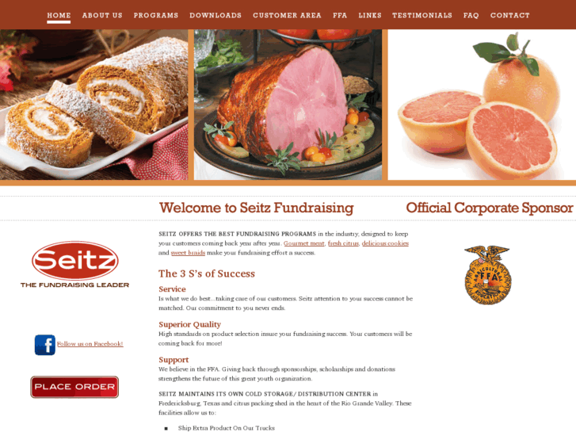

Member Participation

Every FFA member should take advantage of the variety of activities that the FFA has to offer. Each different activity that an FFA member participates in will be worth one point. Participation also helps to determine who will get the star awards. Sign in sheets will be at each activity held, please make sure you get your name on the sheet to receive credit. Senior Stoles can be earned by earning 10 points in their senior year.

Activities:

- Chapter Meetings
- Community Service Activities
- LDE’s – District, Area, State
- CDE’s – Invitational, Area, State
- Jackpot, County and Major Shows
- Leadership Camps
- District, Area, and State Convention

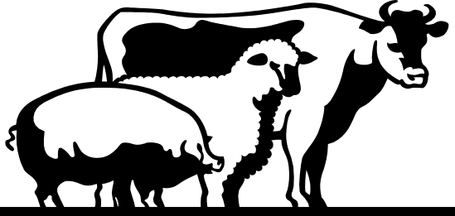
FFA Dues

You are an FFA member by being enrolled in an Agricultural science class. Lumberton ISD will automatically pay your FFA membership dues. Membership also includes a subscription to the FFA Horizons magazine which arrives sometime after January 1st.

FFA Jackets and Ties/ Scarves

FFA Jackets can be purchased for about $65.00. All members are encouraged to purchase a FFA Jacket, especially if you have plans to compete on LDE or CDE teams. Jackets are ordered through the National FFA Store at: http://shopffa.org/products/2/OFFICIAL-DRESS/

Jr. FFA

Jr. FFA membership is open to students in 3rd through 8th grades who are showing livestock projects, and should have an older sibling enrolled in the Lumberton FFA program or have a parent who works in the school district. Dues for Jr. Members must be paid to the Lumberton FFA before October 1, 2021. Dues will be $25.00. Since they are not enrolled in high school Ag courses, they are not eligible to participate in high school FFA events, but they are eligible to show in all stock shows.

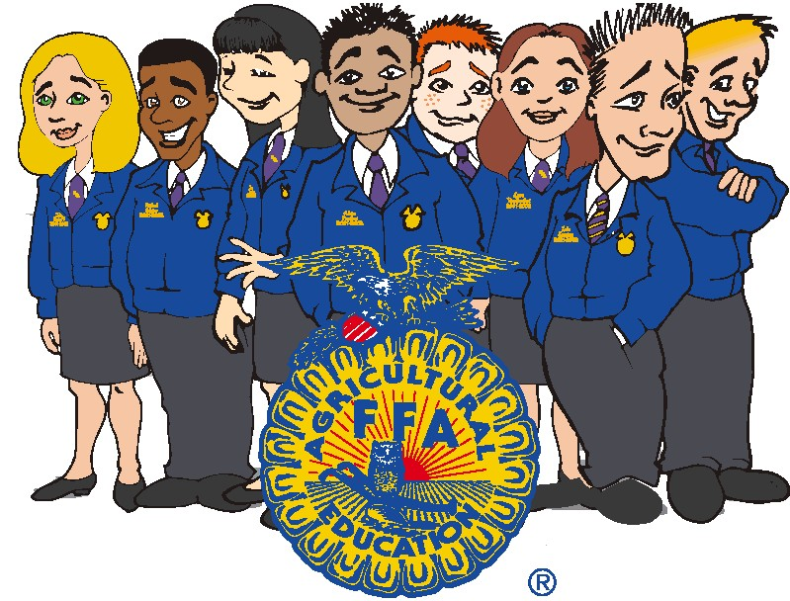
FFA and Agriscience Department
Code of Conduct

FFA Members should conduct themselves at all times to be a credit to their organization, chapter, school, community, and family.

Requirements and Expectations at School and During All School Sponsored Activity:

FFA Member should:

1. Communicate in an appropriate manner.
2. Demonstrate good sportsmanship by being modest in winning and generous in defeat.
3. Respect the rights of others and their property.
4. Be courteous, honest and fair with others.
5. Dress neatly and appropriately for the occasion as outlined in the Lumberton ISD Student Handbook.

FFA Members Will Not:

1. Be a part of robbery or theft.
2. Assault or vandalize people or their property.
3. Fight or be a part of a violent situation.
4. Use or have in their possession fireworks or firearms of any type.
5. Be a part of sexual harassment situations.
6. Use unethical practices to show or exhibit their projects.
7. Partake, possess, or be under the influence of alcohol beverages.
8. Partake, possess, or be under the influence of tobacco or tobacco related
paraphernalia.
9. Partake, possess, or be under the influence of illegal substances.

Consequences:

Will be dealt with through school administration.

Supervised Agricultural Experience Program

A unique aspect of the Agricultural Science Program is the Supervised Agricultural Experience Program, or SAEP. It enables students to feed and exhibit livestock projects, develop agricultural crop or horticultural enterprises, Ag mechanics projects, or experience the other aspects of the agricultural industry.
The SAEP is a powerful tool that teaches responsibility, time management, commitment, teamwork and sound financial practices.

Important Notice

It is strictly prohibited to administer any type of vaccine, drug, spray, feed additive, or substance internally or externally without first receiving approval of the Agriscience teachers or local veterinary. All substances used on the animal must be approved for use on the animal or be recommended by the Agriscience teacher or local veterinary. All students are expected to read and agree to abide by the Animal Welfare Agreement that can be found on the following pages.

Estimated Cost of Livestock Projects

Species | Time Duration | Cost | Feed/Track
Cattle | 12 months | $1,500-4,000 | $1,500
Swine | 5 months | $250-600 | $600
Sheep | 7 months | $250-600 | $350
Goats | 7 months | $250-600 | $350

Livestock Showing Requirements

Students will not receive meal money for livestock shows.

Stock Show Eligibility
To be eligible to participate in any livestock show, students must meet the following requirements:

- Be enrolled in an agricultural science class.
- Be a member in good standing with the Lumberton FFA Chapter (dues paid).
- Meet TEA guidelines for academic eligibility.
- Have paid entry fees on time and meet show requirements.
- Have approval of agricultural science teacher.
- Attend at least 90% of the chapter meetings.

Show Entries
The agricultural science teachers will assist in making arrangements for participation in Junior Shows at the Hardin County Youth Project Show, South Texas State Fair, Fort Worth, San Antonio and HLSR. Entries in all other shows will be the responsibility of the student.

Travel to and from Shows
Students may be responsible for some personal travel to and from livestock shows when it cannot be provided by the agricultural science teacher. Sometimes this may include transportation of livestock.

Discipline While at Shows
Livestock shows are an extension of the Lumberton ISD Classroom; therefore students will be responsible for their personal conduct. All school rules are in effect at these shows.

Animal Care at Shows
While at livestock shows, each student will be responsible for all feeding, care and grooming of his/her respective animal(s).

Equipment/Trailer Use
Arrangements must be made for the use of any equipment belonging to the FFA. Clippers, blowers, and scales must be returned in a diligent manner so that others may be able to use them. The use of livestock trailers will be limited to the agricultural science teachers. Any equipment lost, stole, or destroyed while in the possession of a student will be replaced at the expense of the student.

Specific Show Rules
It is the sole responsibility of the exhibitor to be familiar with all rules pertaining to his/her livestock project (this information includes weight limits, entry requirements, age, ect.) This information may be obtained from the agriscience teachers or by visiting the web sites of the shows you are entering. (see website reference page)

Recommendations for Feeding and Care of Animals
The feeding and care of the animals is a very important aspect of the livestock project. Many authorities believe it as important as purchasing a high quality animal. All authorities believe it is responsible for at least 50% of the success or failure of a project. Below is a list of several proven practices which if done consistently, will lead to success in the show ring.

Daily Care/Feeding
The daily routine of feeding and care is very important. All animals respond well to an organized routine. They should be fed twice daily in most cases. Your feeding program will be tailored to your particular animals as recommended by your Agriscience teacher or your animal breeder. Your choice of feeds will be up to you based upon your particular situation. It is best to discuss with the Agriscience teachers the feeding program that you are going to use.

Halter Breaking or Teaching an Animal to Lead
One of the more important considerations that arise early in the feeding period is teaching the calf, lamb, or goat to lead with a halter or collar. The animal must be worked daily. This is no easy task and sometimes can be very time consuming. Consistency is the key. Some animals learn more quickly than others do, but normally this can be accomplished in the first several weeks. The animal must also be trained to stand correctly and calmly. This is critical, as in some cases the judge may want to handle the animal. The practice will require several additional hours each week.

Disease Prevention
Your animal’s pen must be kept clean on a daily basis. They will help reduce fly problems and help in keeping the animal clean. Regular worming for internal parasites and vaccinations for more serious diseases is recommended. A close examination of your animal’s feces, appetite, and attitude can help you assess its general health.

Approved Livestock Surgical Practice
Many times it will be necessary to perform surgical procedures on livestock which will improve their general appearance. Some of these practices may be performed by the Agriscience teachers; however if the parent would rather have the work performed by a veterinarian, it is understandable. Regardless of who does the procedure, the parent must realize there is always the possibility of complications. The owner must accept all risks of illness or death of an animal.

Weighing on a Regular Basis
Knowing your animal’s weight and weighing on a regular schedule is very important. Weight gain or loss is a good indicator of how well the animal is progressing. An Agriscience teacher will weigh animals twice a month, and weigh large animal species weekly 60 days prior to HCYPS and YMBL check-in dates. It is particularly important near show time, as weight limits and weight classes are sometime critical to placing the animal. It is also important to know the minimum and maximum weight limits for the species you are showing and the show you are entering.

Grooming Livestock for the Show
During the latter part of the feeding period, much time must be devoted to grooming the animal. Brushing and combing your animal are important daily routines. Washing and clipping your animal will also be done on regular intervals to get a good view of how the animal is growing and progressing. In most cases, all animals will be clipped prior to the show to meet maximum hair requirements of the show that you are entering.

Major Stock Shows Attended by the Lumberton FFA

The Lumberton FFA attends three school approved major stock shows (3 major and 2 regional). These include the Junior Shows at: Ft. Worth, San Antonio, and Houston (major) and Hardin County Youth Project Show, and the South Texas State Fair (regional). Any additional shows in which students wish to attend may be done with the owner’s responsibility. If students meet all eligibility requirements and have an adequate number of extracurricular days, they may attend on their own. It should be known that the Ag teachers will not be able to attend or provide transportation to any shows other than the ones listed above.

Source List

Show Supplies

Sullivans Show Supply 800-588-7096
(call for a catalog)

Texas Show Supply 903-229-0863
(call for a catalog)

Tractor Supply – Beaumont 409-892-1949

Feed Stores

Sam’s Western Store – Beaumont 409-842-2625

Hardin Count Farm and Ranch – Sour Lake 409-287-0681

Mid-County Farm & Feed - Nederland 409-722-4933

Dayton Farm & Ranch - Dayton 936-258-9891

Five Star Feed - Port Arthur 409-736-0777

Local Veterinarians

Buna Animal Hospital 409-994-5986

Sour Lake Veterinary Clinic 409-287-2288
Dr. Eric Metteauer

Riceland Veterinary Clinic 409-253-2179
Dr. Rusty Hall

Forms

On the following pages are the forms, which need to be returned to the agscience teachers. If you are raising an animal off campus we need the animal welfare agreement. Also, the acknowledgement form indicating you have received the handbook needs to be filled out and returned to your Ag teacher by October 29, 2021

Handbook Acknowledgement Form

This Lumberton FFA Handbook has been published to help your son/daughter gain the greatest possible benefit from his/her agricultural science/FFA opportunities.

The FFA needs your cooperation. It is very important that each FFA member understands the opportunities and regulations outlined in this handbook. Parents are to encourage their son/daughter to abide by all rules or regulations set forth in this handbook. Please go over all agreements outlined in this handbook and return them to your Agriscience teacher.

Your signature and that of your child acknowledge the receipt of this FFA Member Handbook and the agreement to take full advantage of all the opportunities that are available to members.

__________________________________ __________________
Printed Name of Student Date

__________________________________ __________________
Student Signature Date

__________________________________ ___________________
Parent Signature Date

Date Received ______________________ Received by___________________

**The following forms must also be returned
1. Student Medical release and FFA Permission Form
2. Animal Welfare Agreement (if housing livestock animals off campus)
Student Medical Release and FFA Permission Form 2021-2022

This form certifies that ______________________________ (student name) has permission to travel and attend FFA meetings, livestock shows, competitions, conventions, and other FFA activities during the 2018-2019 school year. Also, the person in charge has my authorization to obtain medical attention for my child should the need arise.

Students Social Security Number:_______________________________ Date of Birth:___________________

Mothers Name:___________________________ Work/Cell Phone Number:_____________________________

Fathers Name:____________________________ Work/Cell Phone Number:_____________________________

Address: ____________________________________________________________________

Insurance Company:______________________________________ Policy Number:________________________

Company Address:___________________________________________________________________________________

Family Physician:_____________________________________________ Phone Number:_____________________

Known Allergies or Health Problems:______________________________________________________________

_______________________________________________ ________________________
Student Signature Date

_______________________________________________ ________________________
Signature of Parent or Legal Guardian Date

Animal Welfare Agreement

As a student member of the Lumberton I.S.D. and Lumberton FFA Chapter who is currently raising an animal project, I know of the importance of the humane treatment of our livestock, poultry, and rabbit projects.

1. I agree that my project(s) will be fed on a daily basis throughout the feeding period with a feed ration and schedule approved for my animal(s) by the Agricultural Science Teachers or animal breeder.

2. I agree that the animal’s pen or stall will be cleaned by me daily by removing any
manure and any soiled bedding.

3. I agree that my animal(s) will be provided with fresh water and fed daily with all
watering and feeding equipment remaining clean.

4. I agree that my project(s) will be de-wormed regularly and be provided with veterinary attention when deemed necessary.

5. I agree not to abuse or use excessive force on my project, especially when training or
exercising my animal.

6. I agree not to use any drugs (or unnatural alteration techniques) on my animal without the approval of a veterinarian or my advisor.

7. In the event that I am feeding with a group of other students, I agree that I will share
the feeding and cleaning responsibilities when it is my turn.

I know that failing to meet the standards set by my FFA advisor(s) and those listed in steps 1-7 above, will be removed from the Lumberton FFA show team following the third verbal or written warning from my advisor.

___________________________ ____________________________

FFA Member Signature & Date Parent or Guardian Signature & Date

___________________________ ______________________________
FFA Advisor Signature FFA Advisor Signature

___________________________ ______________________________
FFA Advisor Signature FFA Advisor Signature

